Step-by-Step Guide to Create a Service Request for VM Provisioning in Jira Service Management
- Create a New Service Desk Project
1.1 Access Jira Service Management
- Log in to your Jira instance.
- Navigate to the Jira Service Management section.
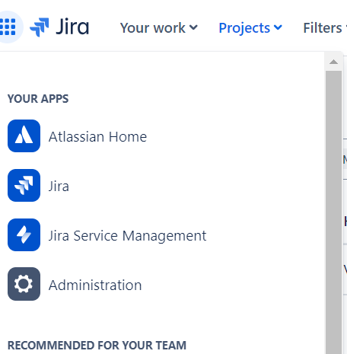
Jira Integration
- Click on Apps > Manage your apps
- Click on Aws service Management Connector > Connect new account.
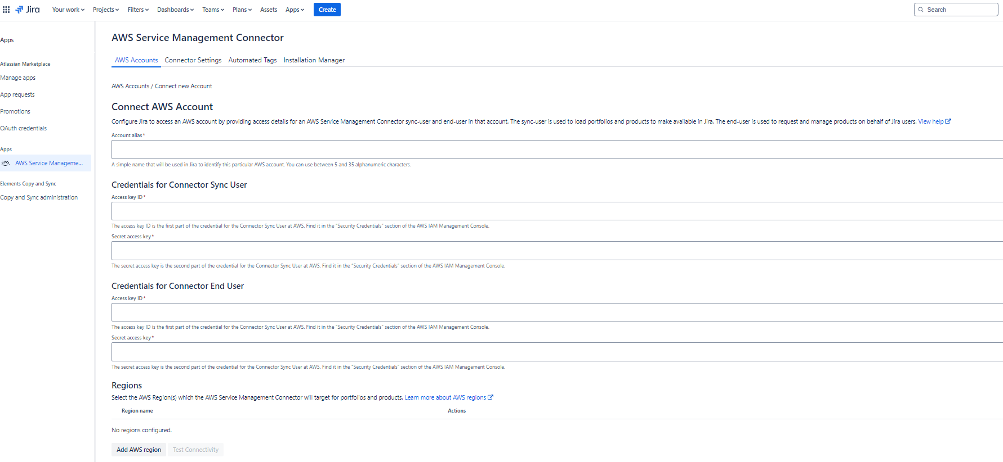

- Click manage > Sync now.
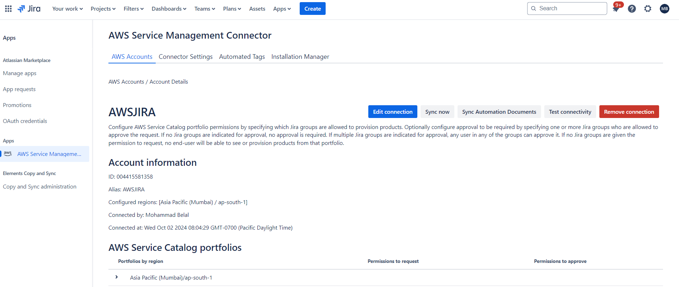
1.2 Create a Project
- Click on Projects > Create project.
- Select the Service Management template from the list of project types.
- Choose IT service management as the template, and click Next.
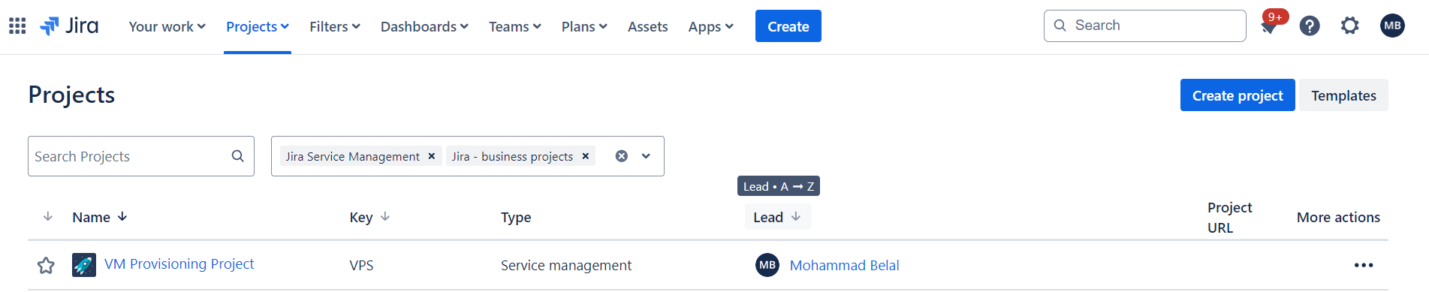

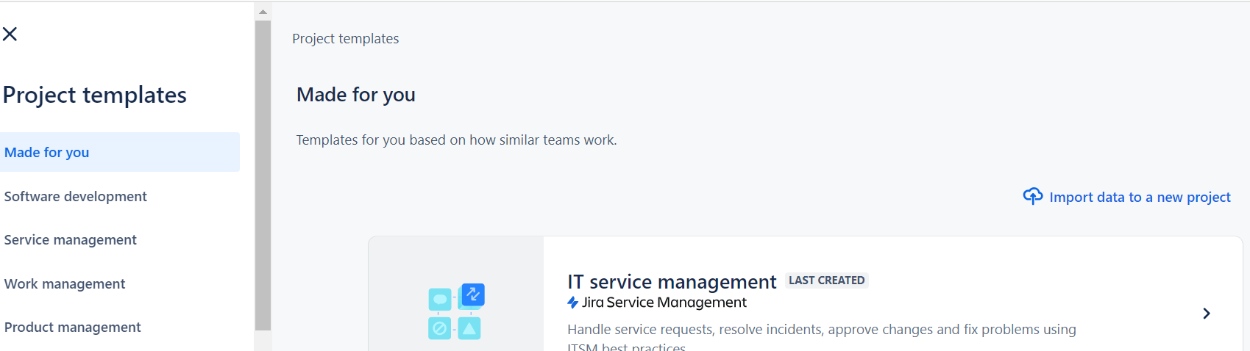
1.3 Configure Project Details
Project name: Enter a name for your project, such as VM Provisioning Service.
Key: Jira will automatically suggest a project key. You can edit it if necessary.
Team type: Select Service since you are providing a service to users (provisioning VMs).
Channel access: Choose whether the project will be Open (anyone can submit requests) or Controlled (restricted to specific users).
Once you fill in all the details, click Create.
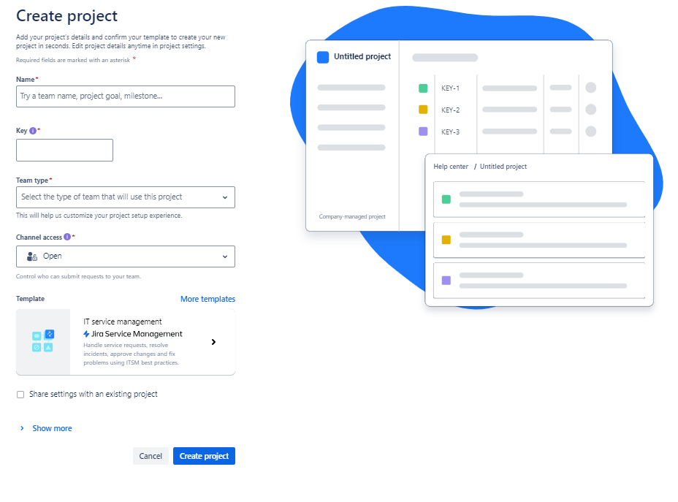
2. Configure Request Types
- Now, you'll create a specific request type for provisioning virtual machines.
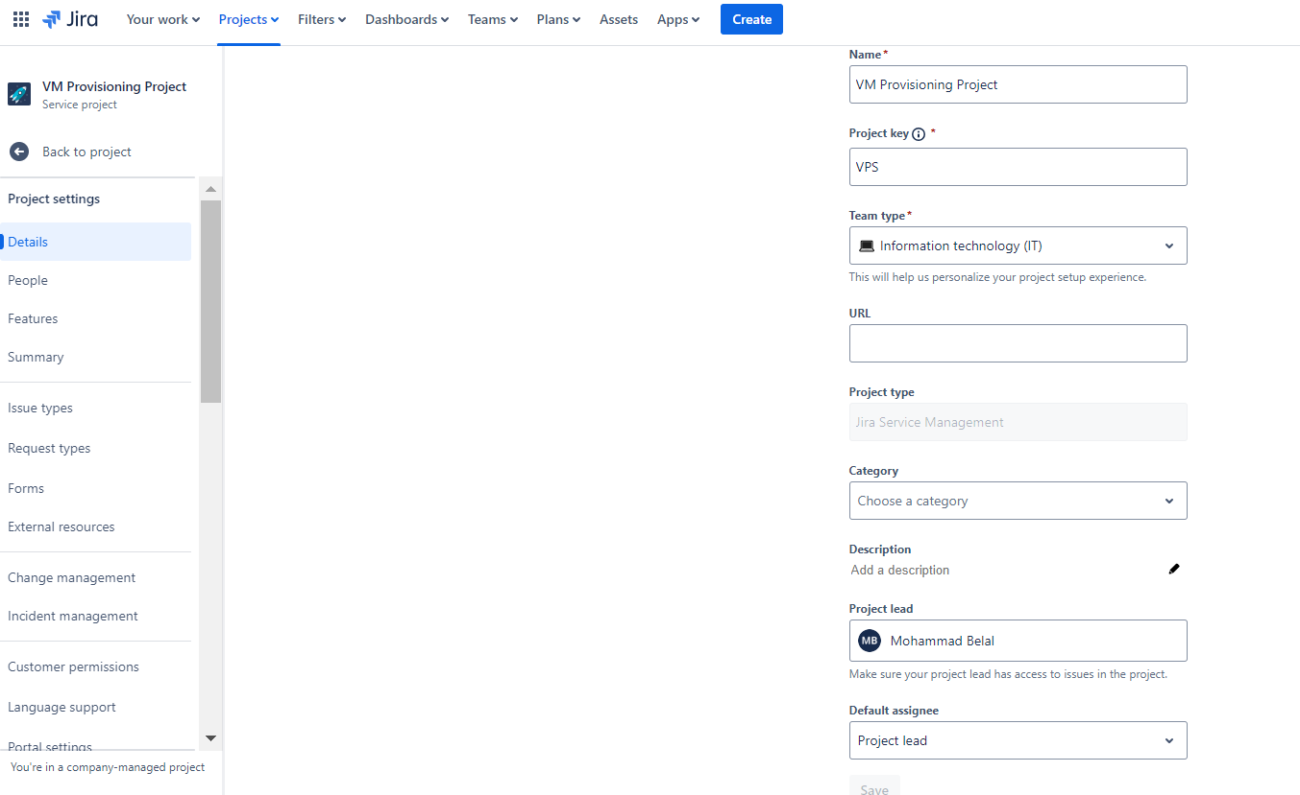
2.1 Navigate to Service Requests
- Go to your project dashboard.
- On the left-hand side, navigate to Project Settings > Service requests.
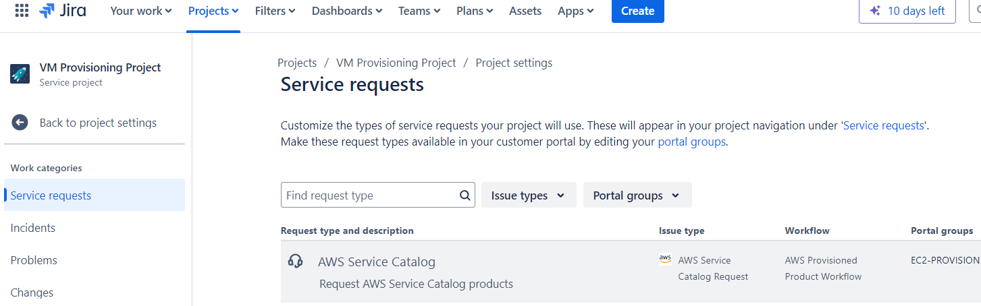
2.2 Create a New Request Type
- Click Create request type in the upper right-hand corner.
- Select Create blank to start from scratch.
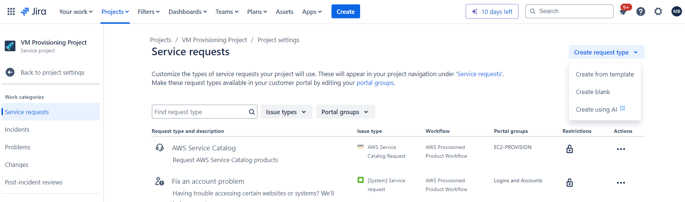
2.3 Configure Request Type Details
You’ll now set up the basic details of the request type.
Name: Enter Provision Virtual Machine.
Description: Add a description to help users understand the purpose of this request. For example:
Description: "Submit a request to provision a new EC2 instance with your specified configurations. Provide details like instance type, region, and AMI."
Icon: Optionally, change the icon to something that represents infrastructure or VM provisioning.
Portal group: Choose or create a new portal group where the request will be listed:
If no relevant group exists, click Create New Portal Group and name it something like VM Provisioning or Cloud Infrastructure.
Issue type: Leave this set to [System] Service request. This issue type will apply the correct workflow and handle service request fields.
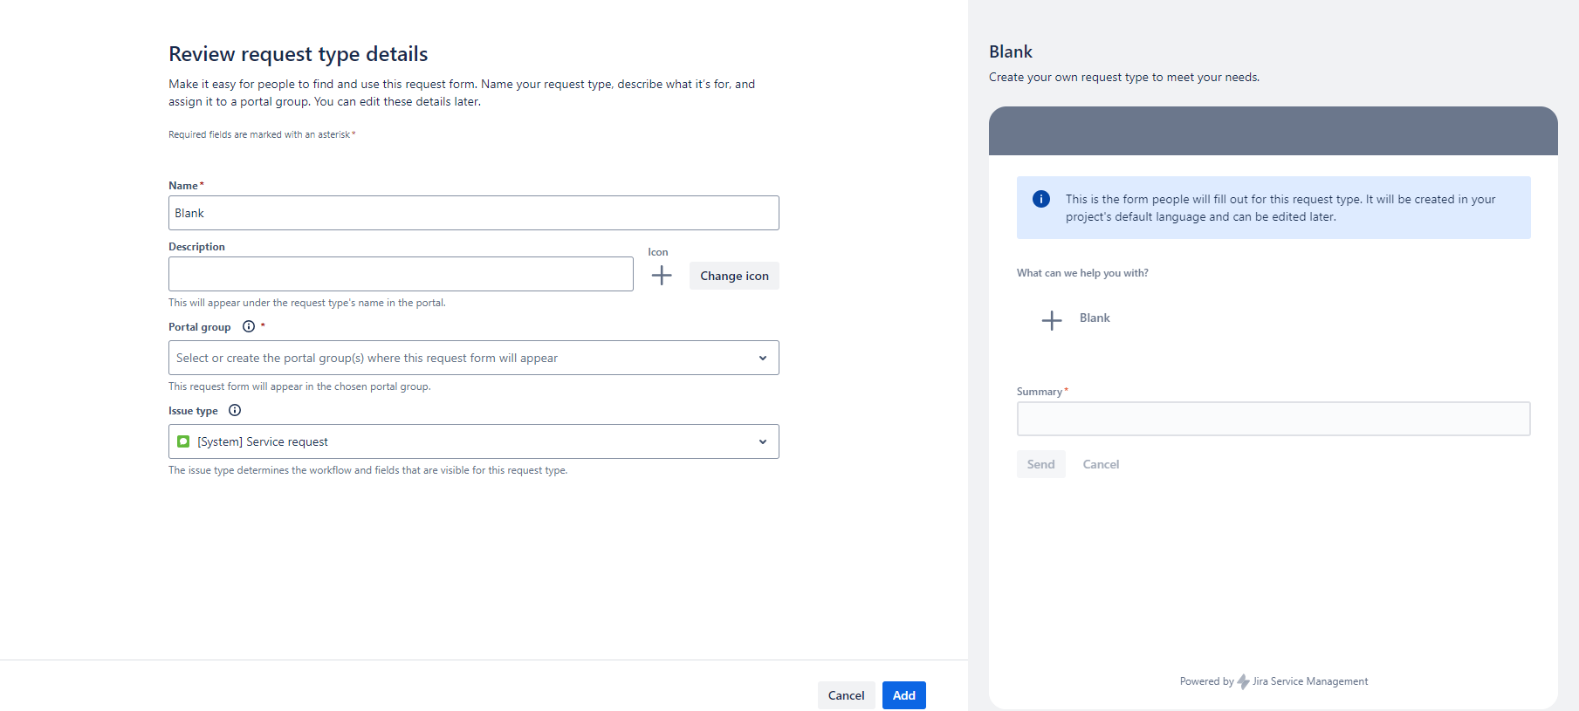
2.4 Save and Proceed
- Click Save to complete the request type creation.
3. Customize the Form Fields
- You now need to configure the fields for the request type so that users can specify the necessary details for VM provisioning.
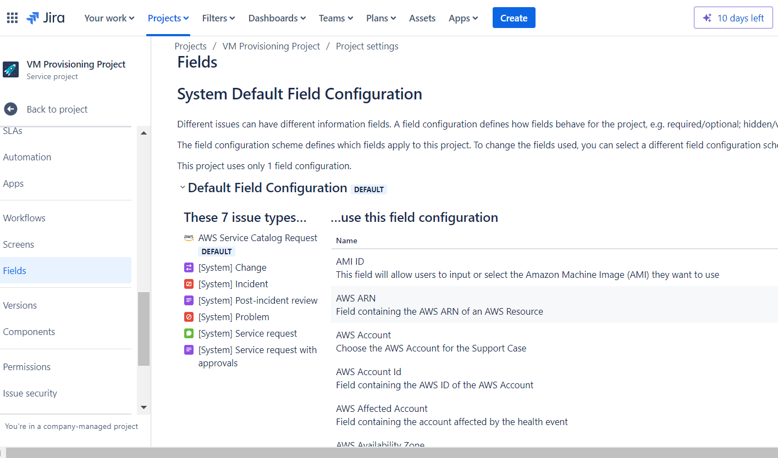

3.1 Access Field Configuration
- After saving, go to Project Settings > Request Types.
- Click on Provision Virtual Machine request type to edit the form.
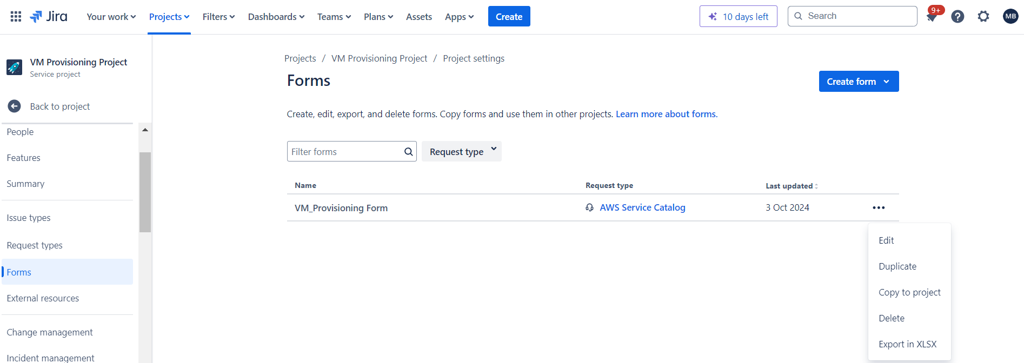

3.2 Add Custom Fields
- Ensure the form captures all the necessary VM details. You can add custom fields by clicking Add Field. For VM provisioning, consider adding the following fields:
Instance Type: Dropdown or text field to capture the type of VM instance (e.g., t2.micro, m5.large).
AMI ID: Text field for users to enter the AMI ID (Amazon Machine Image).
Region: Dropdown to select the AWS region for the VM (e.g., us-east-1, eu-west-2).
Shutdown Date: Date picker to set a future shutdown date for the VM.
Owner Name: Text field to enter the owner's name or email.
- Ensure these fields are marked required if they must be filled out by users.
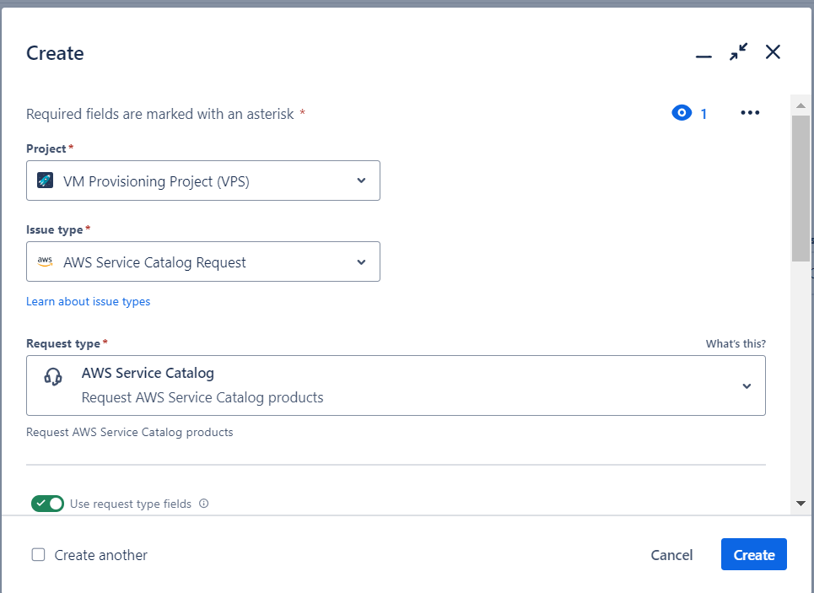

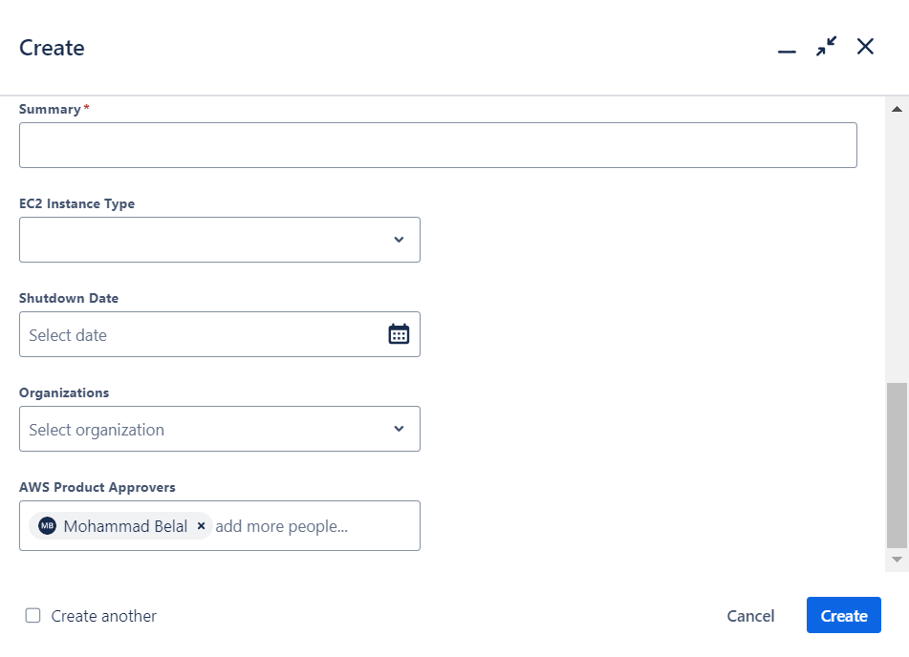

3.3 Save Field Configuration
- Once the fields are configured, click Save to finalize the form layout.

4. Assign Workflow
4.1 Default Workflow
- By default, the [System] Service request issue type will use the default workflow for service requests.
4.2 Custom Workflow (Optional)
- If you need to add approval steps (e.g., manager approval before the VM is provisioned), you can configure a custom workflow:
- Go to Project Settings > Workflows.
- Select the workflow associated with Provision Virtual Machine.
- Add custom statuses and transitions, such as Waiting for Approval, Provisioning, and Complete.
- Ensure that the workflow is aligned with your VM provisioning process.
- 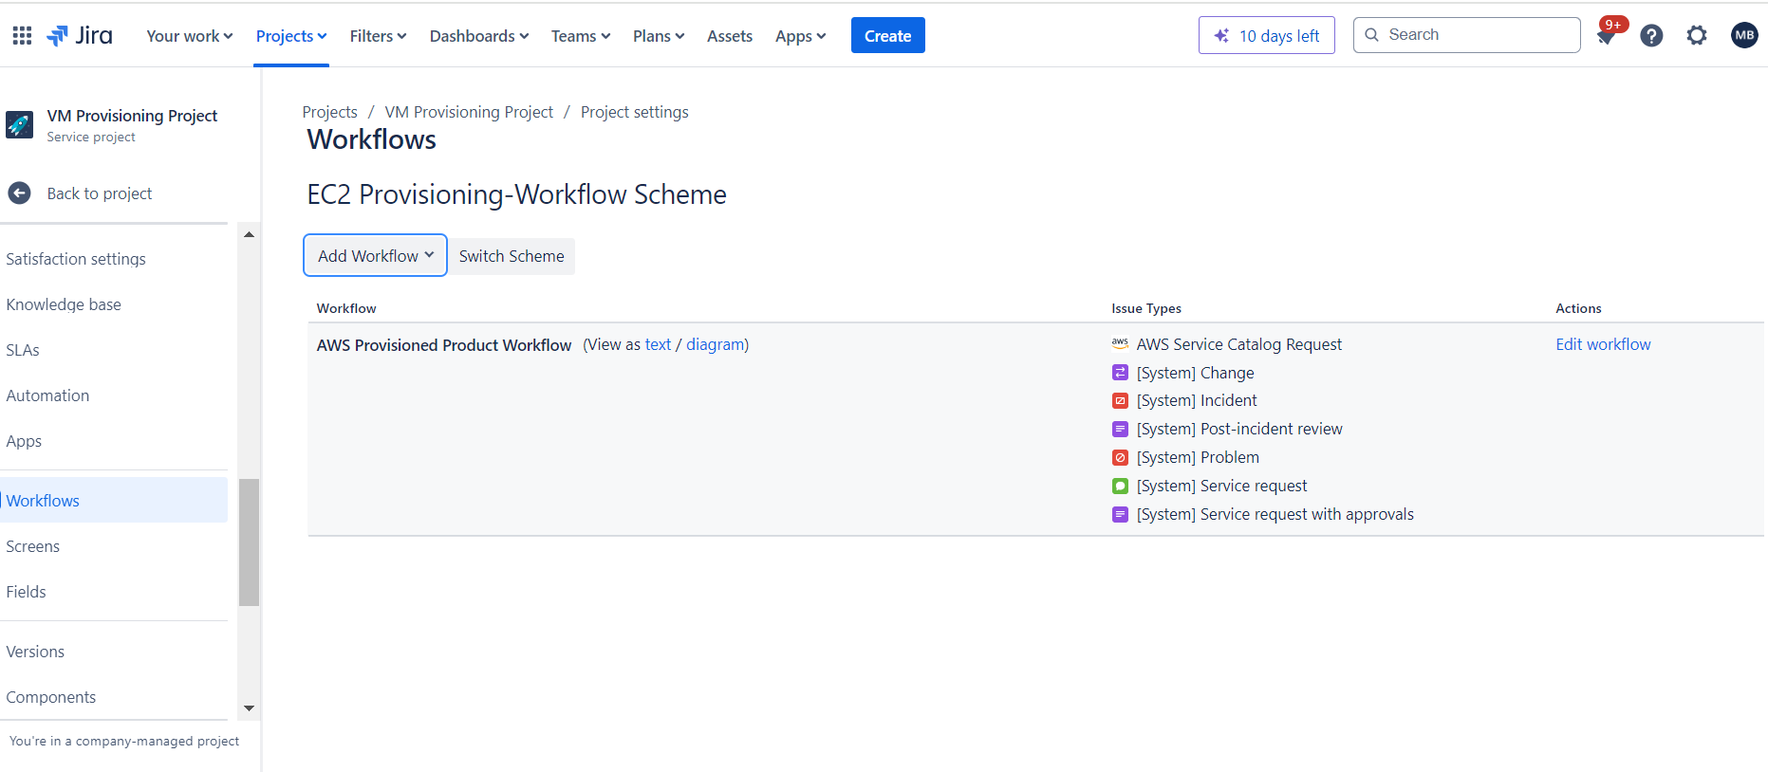
5. Add Automation Rules (Optional)
- If you want to automate certain actions (e.g., assigning a request to a specific team or sending notifications), you can set up automation rules.
5.1 Navigate to Automation
- Go to Project Settings > Automation.
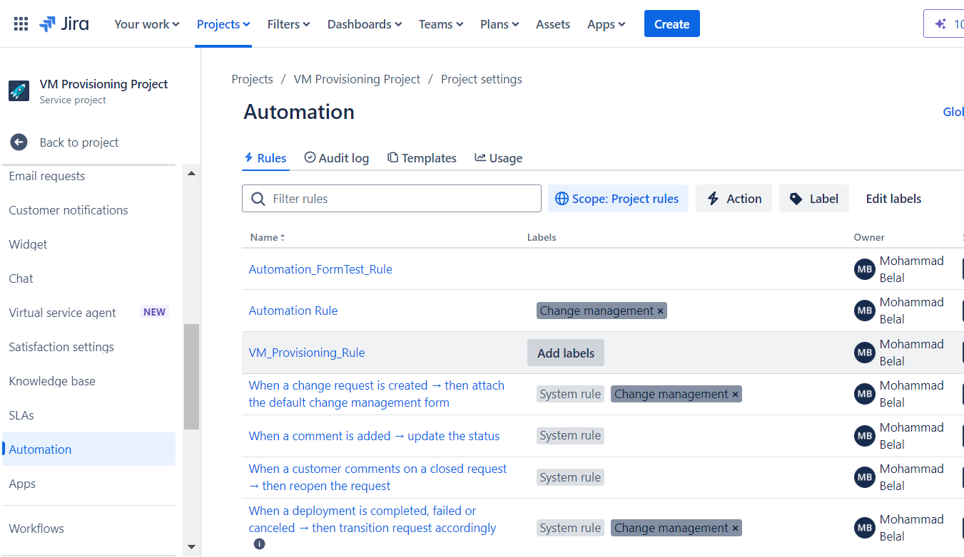

5.2 Create a New Rule
- Click Create rule and set up conditions or triggers based on your needs.
- For example, you might want to auto-assign all VM provisioning requests to an IT team member.
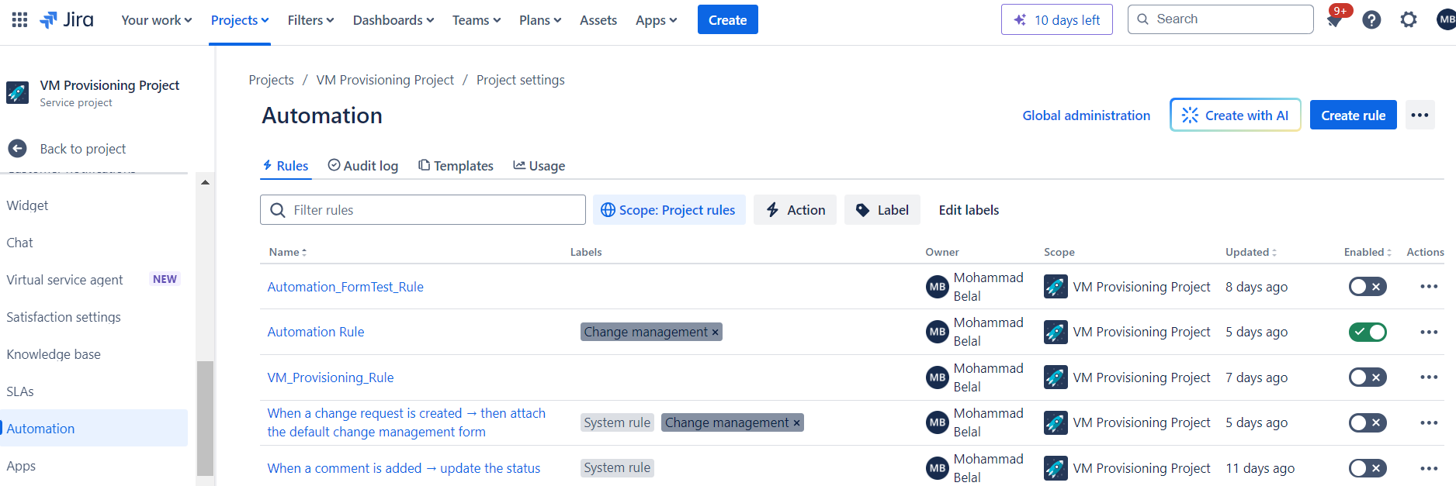
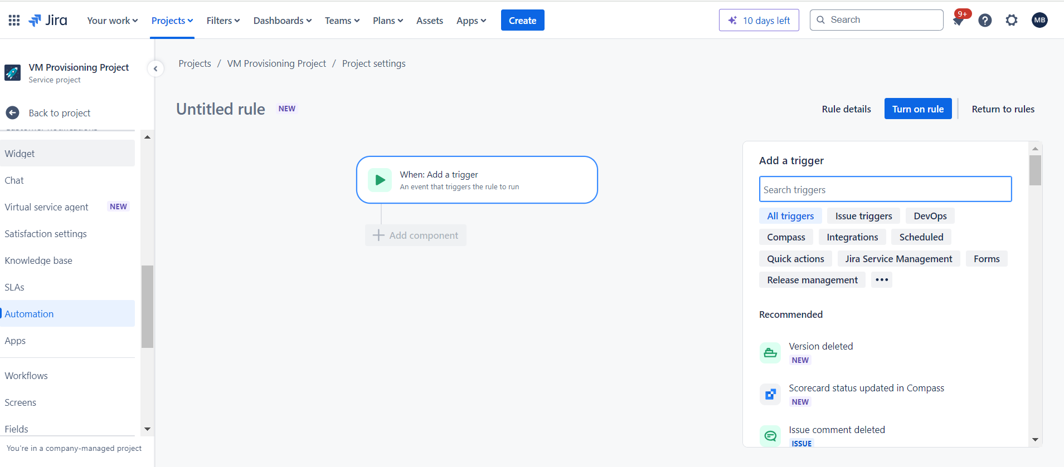

6. Test the Request Type
6.1 Open Customer Portal
- Go to the Customer Portal for your project.
- Click on link: https://mdbelal.atlassian.net/servicedesk/customer/portal/35
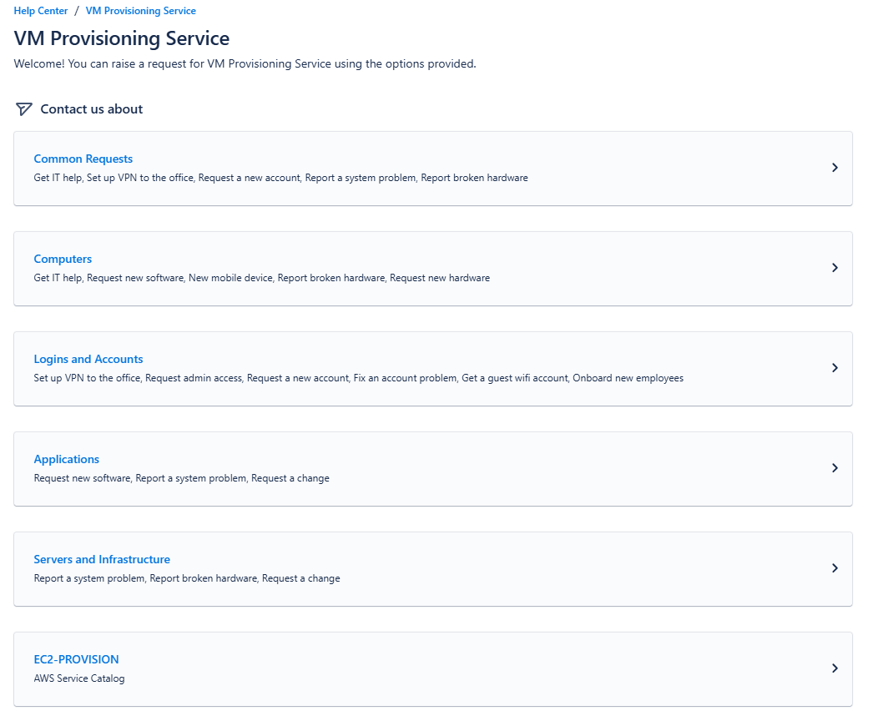
- Click on EC2- Provision.
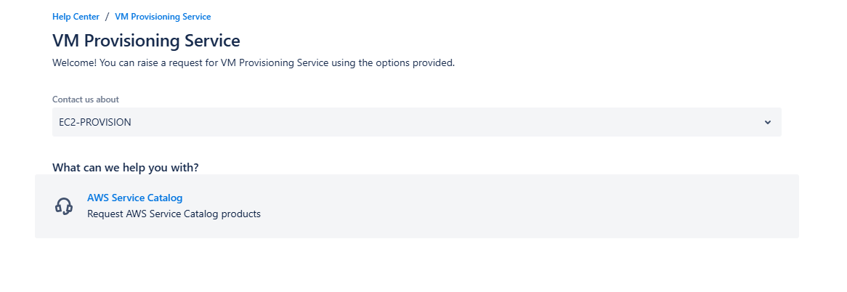
- Click on AWS Service Catalog.
- 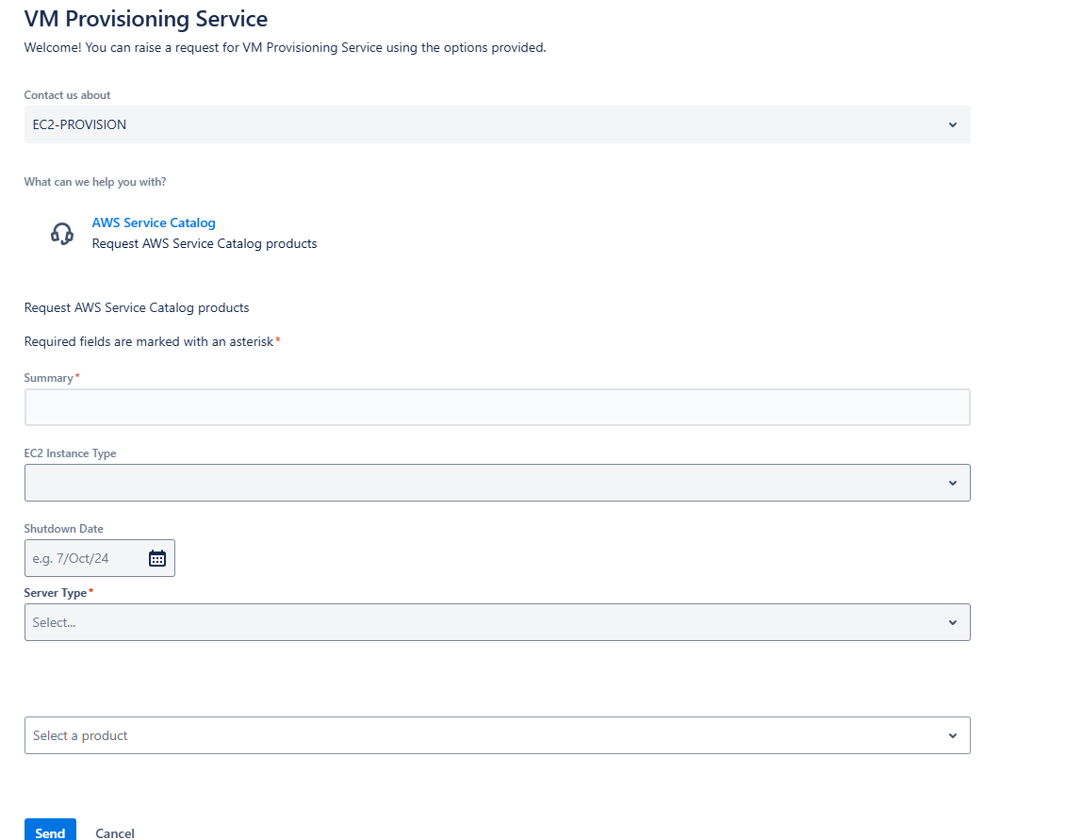

6.2 Submit a Test Request
- Find the Provision Virtual Machine request type in the portal.
- Submit a test request by filling in the fields (instance type, AMI, etc.) to ensure everything is working as expected.
6.3 Review the Ticket in Jira
- After submitting the test request, review the ticket in Jira to confirm that all details are captured and that the workflow is functioning correctly.
7. Review and Finalize
- Once everything is set up and tested, make any necessary adjustments to the fields, workflow, or automation rules. You can now provide users with access to the customer portal so they can start submitting VM provisioning requests.
8. Documentation Review and Publishing
- After completing all these steps, document the process for future reference or for sharing with your team.
Conclusion:
- By following these steps, you've successfully created a service request type in Jira Service Management for VM Provisioning. This allows users to request VMs with custom configurations directly from Jira, integrating with your existing AWS infrastructure.

Prerequisites: Permissions need to be granted to “IAM Role for Updating DynamoDB”
- Role Name: AWSLambdaBasicExecutionRole - Customer managed
- CreateLogGroup
- CreateLogStream
- PutLogEvents
- Role Name: EC2- Launches-ServiceCatalog-Rule- Customer managed
- Scan
- StopInstances

Lambda function for updating login details in DynamoDB -:
import json
import boto3
from datetime import datetime

# Initialize DynamoDB and EC2 clients
dynamodb = boto3.resource('dynamodb')
ec2_client = boto3.client('ec2')
table = dynamodb.Table('EC2InstanceDetails') # Replace with your DynamoDB table name

def get_tags_from_instance(instance_id):
"""Retrieve ShutdownDate and Owner from EC2 instance tags."""
shutdown_date = ""
owner = "unknown"

try:
# Describe EC2 instance tags
response = ec2_client.describe_tags(
Filters=[
{'Name': 'resource-id', 'Values': [instance_id]},
{'Name': 'key', 'Values': ['ShutdownDate', 'Owner']}
]
)

# Parse tags to find ShutdownDate and Owner
tags = response.get('Tags', [])
for tag in tags:
if tag['Key'] == 'ShutdownDate':
shutdown_date = tag['Value']
elif tag['Key'] == 'Owner':
owner = tag['Value']

except Exception as e:
print(f"Error fetching tags for instance {instance_id}: {str(e)}")

return shutdown_date, owner

def lambda_handler(event, context):
# Log the entire event for debugging
print("Received event: " + json.dumps(event, indent=2))

try:
# Extract EC2 instance details
instance_id = event['detail'].get('instance-id', 'no-instance-id') # Default if missing
provision_date = datetime.now().isoformat() # Current date and time
instance_status = event['detail'].get('state', 'unknown') # Default to 'unknown' if missing

# Retrieve shutdown date and owner from EC2 tags
shutdown_date, owner = get_tags_from_instance(instance_id)

# Check if the essential information is present
if instance_id == 'no-instance-id':
raise KeyError('Missing required instance details: instance-id')

# Prepare the item to be inserted into DynamoDB
item = {
'instance_id': instance_id, # Partition Key (unique EC2 instance ID)
'owner': owner, # Owner from EC2 tag
'provision_date': provision_date, # Date and time of instance launch
'shutdown_date': shutdown_date, # Shutdown date from EC2 tag
'instance_status': instance_status # Status of the EC2 instance (running, stopped, etc.)
}

# Insert the item into DynamoDB
table.put_item(Item=item)

return {
'statusCode': 200,
'body': json.dumps(f'EC2 instance {instance_id} record added successfully')
}
except KeyError as e:
return {
'statusCode': 500,
'body': json.dumps(f"KeyError: {str(e)}")
}
except Exception as e:
return {
'statusCode': 500,
'body': json.dumps(f"Error: {str(e)}")
}

Prerequisites: Permissions need to be granted to “IAM Role for StopEC2Instance”
- Role Name: AWSLambdaBasicExecutionRole - Customer managed
- CreateLogGroup
- CreateLogStream
- PutLogEvents
- Role Name: EC2-Unable-StopStart - Customer managed
- Scan
- StopInstances

Lambda function for terminating EC2 as per the shutdown date -:
import boto3
import datetime
import logging
from botocore.exceptions import ClientError

# Configure logging
logging.basicConfig(level=logging.INFO)
logger = logging.getLogger()

def lambda_handler(event, context):
# Initialize the DynamoDB and EC2 clients
dynamodb = boto3.resource('dynamodb')
ec2 = boto3.client('ec2')
table = dynamodb.Table('EC2InstanceDetails')

# Get today's date in various formats
today_date = datetime.datetime.now().strftime("%Y-%m-%d")
today_date_alt1 = datetime.datetime.now().strftime("%m/%d/%y") # MM/DD/YY
today_date_alt2 = datetime.datetime.now().strftime("%d/%m/%Y") # DD/MM/YYYY
today_date_alt3 = datetime.datetime.now().strftime("%d/%b/%Y") # DD/Mon/YYYY
today_date_alt4 = datetime.datetime.now().strftime("%Y-%m-%dT%H:%M:%S") # ISO format

# Log the current date for debugging
logger.info(f"Checking for instances with shutdown date: {today_date}")

# Scan the DynamoDB table for items
try:
response = table.scan()
items = response.get('Items', [])

instances_to_stop = []

for item in items:
instance_id = item.get('instance_id')
instance_status = item.get('instance_status')
shutdown_date = item.get('shutdown_date')

# Check if the instance is running and the shutdown date matches today's date
if instance_status == 'running':
if shutdown_date in [today_date, today_date_alt1, today_date_alt2, today_date_alt3, today_date_alt4]:
logger.info(f"Stopping instance {instance_id} with shutdown date: {shutdown_date}")
instances_to_stop.append(instance_id)

# If there are instances to stop, proceed to stop them
if instances_to_stop:
try:
ec2.stop_instances(InstanceIds=instances_to_stop)
logger.info(f"Stopped instances: {instances_to_stop}")
except ClientError as e:
logger.error(f"Error stopping instances: {str(e)}")
else:
logger.info("No instances to stop.")

except Exception as e:
logger.error(f"Error scanning DynamoDB table: {str(e)}")

return {
'statusCode': 200,
'body': f"Checked and stopped instances with shutdown date: {today_date}."
}

